**EXERCISE:20**

CREATE A PROPER HOMEPAGE OF YOUR OWN USING ANY COMPONENTS AND STYLES.

<!DOCTYPE html>

<html lang="en">

<head>

<meta charset="UTF-8">

<meta name="viewport" content="width=device-width, initial-scale=1.0">

<title>My Homepage</title>

<link rel="stylesheet" href="styles.css">

</head>

<body>

<header>

<h1>Welcome to My Homepage</h1>

<nav>

<ul>

<li><a href="#about">About</a></li>

<li><a href="#services">Services</a></li>

<li><a href="#contact">Contact</a></li>

</ul>

</nav>

</header>

<section id="about">

<h2>About Me</h2>

<p>Hello! I'm a web enthusiast and love creating beautiful websites.</p>

</section>

<section id="services">

<h2>My Services</h2>

<ul>

<li>Web Design</li>

<li>Development</li>

<li>SEO Optimization</li>

</ul>

</section>

<section id="contact">

<h2>Contact Me</h2>

<form>

<label for="name">Name:</label>

<input type="text" id="name" name="name" required>

<label for="email">Email:</label>

<input type="email" id="email" name="email" required>

<label for="message">Message:</label>

<textarea id="message" name="message" required></textarea>

<button type="submit">Send</button>

</form>

</section>

<footer>

<p>&copy; 2024 My Homepage. All rights reserved.</p>

</footer>

</body>

</html>

**OUTPUT:**

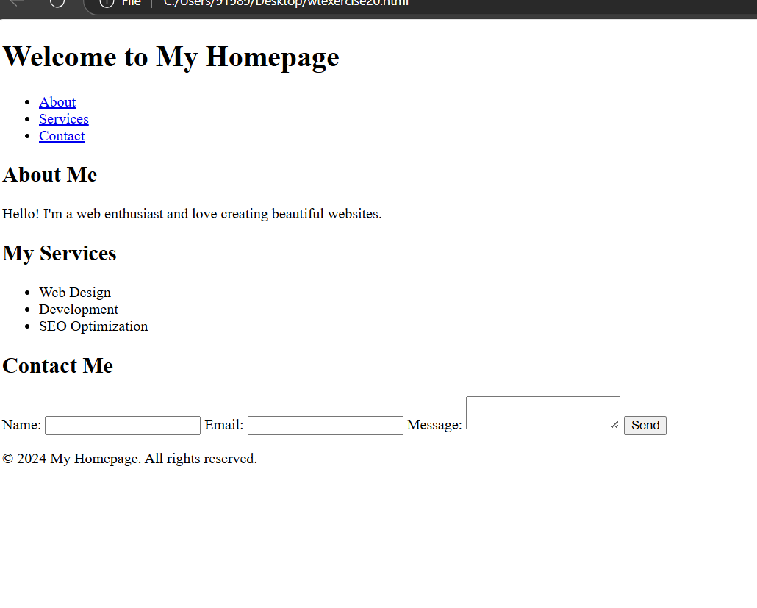

**EXERCISE: 21**

WRITE HTML CODE FOR INCLUDING LOCAL HYPERLINK IN A WEB PAGE.

<!DOCTYPE html>

<html lang="en">

<head>

<meta charset="UTF-8">

<meta name="viewport" content="width=device-width, initial-scale=1.0">

<title>Local Hyperlink Example</title>

</head>

<body>

<h1>Welcome to My Web Page</h1>

<p>This is a paragraph with a local hyperlink to another page.</p>

<a href="page2.html">Go to Page 2</a>

</body>

</html>

**OUTPUT:**

**EXERCISE: 22**

WRIE HTML CODE FOR INCLUDING INTER HYPERLINKING IN A WEB PAGE.

<!DOCTYPE html>

<html lang="en">

<head>

<meta charset="UTF-8">

<meta name="viewport" content="width=device-width, initial-scale=1.0">

<title>Internal Hyperlink Example</title>

<style>

body {

font-family: Arial, sans-serif;

}

section {

margin: 50px 0;

}

</style>

</head>

<body>

<h1>Internal Hyperlink Example</h1>

<nav>

<ul>

<li><a href="#section1">Go to Section 1</a></li>

<li><a href="#section2">Go to Section 2</a></li>

<li><a href="#section3">Go to Section 3</a></li>

</ul>

</nav>

<section id="section1">

<h2>Section 1</h2>

<p>This is the content of Section 1.</p>

</section>

<section id="section2">

<h2>Section 2</h2>

<p>This is the content of Section 2.</p>

</section>

<section id="section3">

<h2>Section 3</h2>

<p>This is the content of Section 3.</p>

</section>

</body>

</html>

**OUTPUT:**

**EXERCISE: 23**

WRITE HTML CODE FOR INCLUDING EXTERNAL HYPERLINKING IN A WEB PAGE.

<!DOCTYPE html>

<html lang="en">

<head>

<meta charset="UTF-8">

<meta name="viewport" content="width=device-width, initial-scale=1.0">

<title>External Hyperlink Example</title>

</head>

<body>

<h1>Welcome to My Web Page</h1>

<p>Visit <a href="https://www.example.com" target="_blank">Example Website</a> for more information.</p>

</body>

</html>

**OUTPUT:**

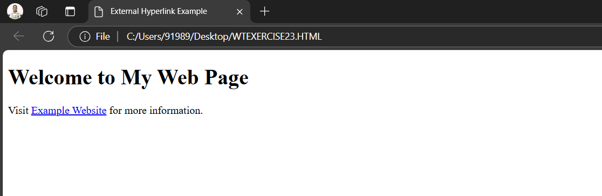

**EXERCISE: 24**

WRITE A CODE TO SHOW EXTERNAL CSS WITH HTML CODE.

<!DOCTYPE html>

<html lang="en">

<head>

<meta charset="UTF-8">

<meta name="viewport" content="width=device-width, initial-scale=1.0">

<title>External CSS Example</title>

<link rel="stylesheet" href="styles.css">

</head>

<body>

<h1>Hello, World!</h1>

<p>This is an example of using external CSS.</p>

</body>

</html>

**OUTPUT:**

